Market Analysis Report for National Clothing

Analysis Questions

1. *What is the correlation (R2 value) between sales and income?*

The correlation value is **0.78** indicating a strong positive correlation as we can see from the scatterplot that as Average sales increase, Average income increases.

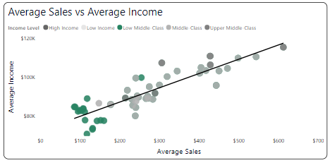

1. *What is the correlation (R2 value) between customer ratings and product return rate?*

The correlation value is **0.69** and this is a relatively strong negative relationship as we can see from the scatterplot that as customer ratings increase, return rate decreases.

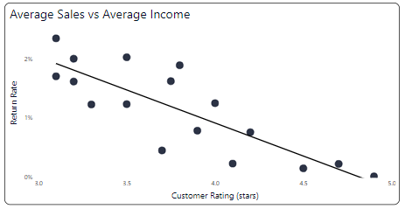

1. *What are the linear regression formulas to predict customer income from customer sales?*

Y = 72.43X + 72638.21

Y is Customer Income & X is Customer Sales

1. *Which customer do you predict has the highest income?*

Customer with the highest predicted income is **Jon Little**

1. Which product will be advertised the most?

**Sweater** given that a large number of the customers fall into the **Low Middle-Class** & Middle-Class income category and these categories of customers have the largest predicted income combined and account for 75% of sales in the last 6 months.

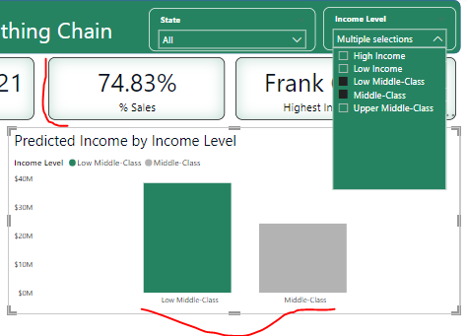

Additional Findings

* Top 3 states with highest number of customers (**California, Texas, Florida**) account for approximately **38%** of sales in the last 6 months.   
  **Illinois** surprisingly accounts for **7.1%** of sales in the last 6 months despite having 46 customers. In comparison, Florida with 108 customers accounts for 6.7%.

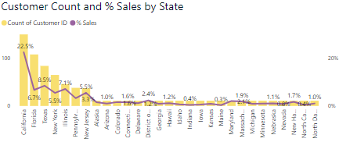

* We have relatively high number of customers in Florida & New Jersey when compared to states with similar population numbers.

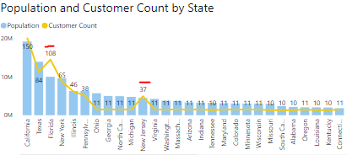

* Highest income Age Group (based on predicted income) are those between 36 – 50 years. They also contributed 53% of sales in the last 6 months.  
  Those in the Middle-Class income category whilst having the second highest predicted income accounts for 45% of total sales in the last 6 months.

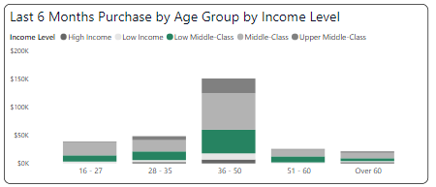

Recommendations

* Based on my analysis, most of our sales revenue comes from customers in the Middle-Class income category (45%) and 36 – 50 age group. We should look to allocate more advertising budget for these categories of customers.
* While states with large populations account for most of the customers count, New Jersey while relatively small also has an impressive number of customers. We should look to advertise more here and see if we can get more customers from this state.  
  Illinois is also a potential great advertising location as it accounts for 7.1% of sales in the last 6 months despite having 46 customers.
* We should advertise Sweaters the most given that a large number of the customers fall into the Low Middle-Class & Middle-Class income category and these categories of customers have the largest predicted income combined and account for 75% of sales in the last 6 months.